BIO-DATA 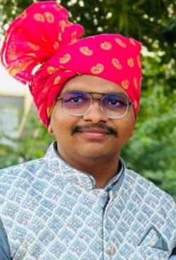

PERSONAL DETAILS

NAME : RONAKSINH SUBHASHCHANDRA PARMAR

DATE OF BIRTH : 17/07/2002

BIRTH PLACE : LAKODARA

EDUCATION : DIPLOMA IN CANICAL ENGINEERING

RELIGION : HINDU

RASHI : TULA

GOTRA : VASHISTH

OCCUPATION : CHEMICAL ENGINEER IN RUBAMIN COM.HALOL

FAMILY DETAILS

FATHER NAME : SUBHASHCHANDRA RAMESHBHAI PARMAR

OCCUPATION : GOVERMENT PRIMARY TEACHER

MOTHER NAME : MEENABEN SUBHASHCHANDRA PARMAR

OCCUPATION : HOUSE WIFE

BROTHER NAME : PRATHAMSINH S.NPARMAR

CONTACT DETAILS

ADDRESS : B/34 PRAMUKH DARSHAN SOCITY,NAVA-BAZAR,KARJAN

CONTACT NO. : RONAKSINH -7573918071

SUBHASHCHANDRA - 8238075288

